Questions | Answer
Q1: Approximately how long ago did the source state that network engineers primarily possessed domain-specific knowledge to manage networks using the command-line interface? | 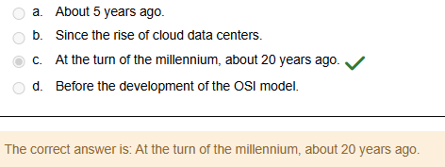
Q2: Which two movements have significantly blurred the lines between network engineers, systems engineers, and developers today? | 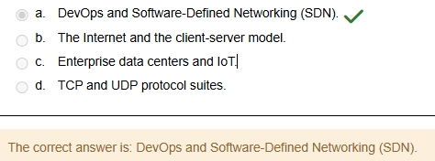
Q3: The author states that the book assumes the reader has some hands-on experience in managing networks, as well as what specific level of understanding regarding protocols? | 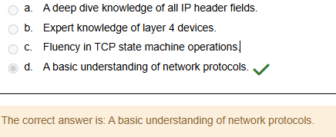
Q4: What online resource is recommended by the author for brushing up on Python tutorials from the Python Software Foundation? | 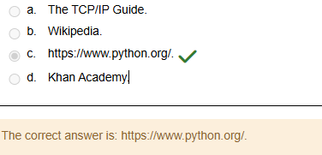
Q5: Which foundational concept does the source note a typical network engineer should be familiar with, even if they don't remember the exact TCP state machine? | 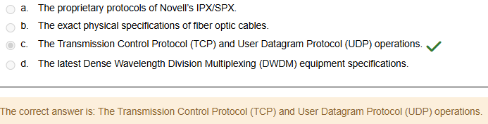  The Transmission Control Protocol (TCP) and User Datagram Protocol (UDP) operations.
Q6: To a network engineer, how is the Internet defined? | 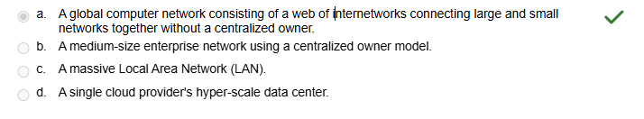  A global computer network consisting of a web of internetworks connecting large and small networks together without a centralized owner.
Q7: What is the primary function of an Internet Service Provider (ISP)? | 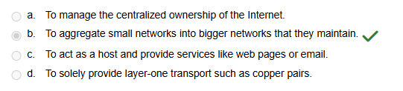  To aggregate small networks into bigger networks that they maintain.
Q8: Hosts are described as end nodes on the network. With the rise of the Internet of Things (IoT), the broad definition of a host can be expanded to include which of the following? | 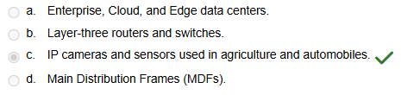
Q9: If servers and hosts are considered cities and towns, what are network components considered to be? A. The local area networks (LANs). | 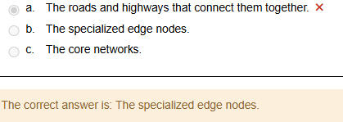
Q10: What are the three broad categories into which data centers can generally be classified? A. Access, Distribution, and Core data centers. | 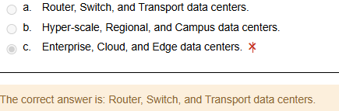
Q11: In the User-IDF-MDF example of the enterprise three-layer network design, which layer is analogous to the ports each user connects to? A. The core layer. | 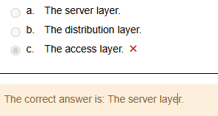
Q12: Why are cloud data centers typically built close to power plants? A. To be closer to the Arctic Circle for better cooling. | 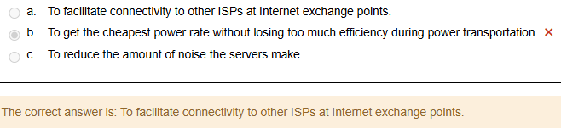
Q13: Due to the tremendous pressure on the network put by latency and redundancy requirements in cloud data centers, what typical network design is utilized? A. A three-tier campus network. | 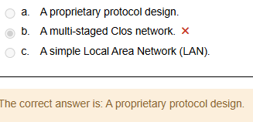
Q14: What is the primary reason for developing Edge data centers? A. To introduce new proprietary protocols. | 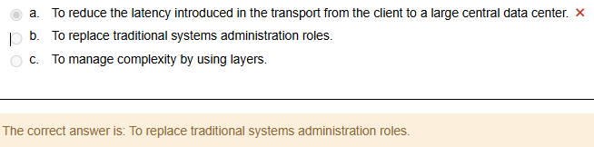
Q15: What technological applications are cited as examples of intelligent edge nodes that need to route packets locally or make split-second decisions? A. The OSI model and the client-server model. | 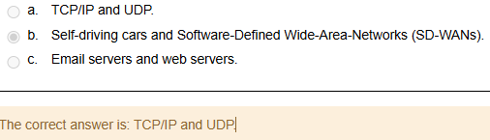
Q16: Networking breaks down complexity by modeling the functions of its elements using what concept? A. Functions. | 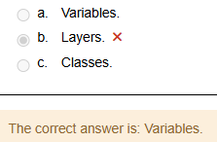
Q17: The OSI model was initially worked on in the late 1970s and later published jointly by the International Organization for Standardization (ISO) and which other entity? | 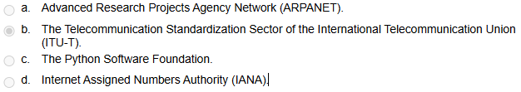  The Telecommunication Standardization Sector of the International Telecommunication Union (ITU-T).
Q18: What are the OSI layers (5 to 7) combined into in the TCP/IP model? | 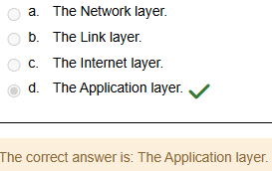
Q19: What is the primary job of the Internet Protocol (IP), which sits at layer 3 of the OSI model? | 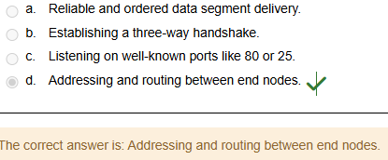
Q20: What functional characteristic distinguishes TCP as a connection-oriented protocol from UDP? | 